Eazy-Admin by Sanele Manyela & Samkelwe Ngalimane

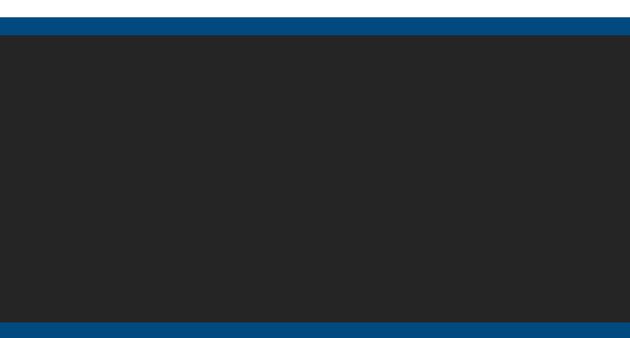

ReactJS Project Headline

Executive Summary

The React application project aims to make easy activities associated with viewing and editing supplier and contract data. The application uses an API to read and store the data used.

**System investigation**

* **Software Purpose**

The software application is being designed to view supplier and contract data as required and be able to access API data. The application will also allow for the contract and supplier data to be updated.

The application has the following objectives:

* Aid an administrative user in viewing data of suppliers and that of contractual agreements.
* Simplify manipulation of data used by the application.
* **Software system capabilities**

The software application will access API data and display supplier data and contract data as required. The application will also be able to update both the supplier and the contract data.

* **Software system actors**

The application will be used by administration personnel.

* **Feasibility Study**
  + **Statement of the problem**

Design and build a platform to view Supplier and Contract Data, using React for the frontend. The platform should be able to access the API Data and display it as required.

* + - * **Summary of findings**
        + **Technical feasibility**

**React** (also known as **React.js** or **ReactJS**) is a free and open-source front-end JavaScript for building user-interface based on UI components. React will be  used for creating the platform. React allows working with and making API calls.

* **Legal feasibility**

The application will be subject to Protection of Personal Information Act (POPIA) to protect supplier data and contract data. POIPA ensures customer’s personal details are treated in a legitimate and respectful manner. The Protection of Personal Information Bill states that personal information must be used explicitly defined and lawful purposes related to a function or activity of your business. It is the business’ responsibility to ensure a customer’s information is complete, accurate, truthful, and up to date.

* **Project Planning**
  + **Project background**

**Description:** This project is an endeavour to design and develop a  platform using React as a choice of technology for the frontend  development. The platform will be able to access API data and display  it as required. The users of the final deliverable will be administrators  who will view supplier and contract data.

**Project start date:**07 December 2021

**Project end date:**21 January 2022

**Scheduling strategy:** Schedule from project start date

**Calendar:**The project will use the standard Gregorian calendar. The  project working days are Monday to Friday.

* + **Project Team**

Team members

* + - * Sanele Manyela
      * Samkelwe Ngalimane

Roles

The team roles for this project are dynamic in their nature, both team members are free to take on the roles of project manager, systems/software analysts, software developer, software tester, and software architecture.

* + **Project Scope**

The scope of the project specifies a requirement to design and build a  platform to view supplier and contract data, using React for the  frontend. The platform must be able to access API data and display it  as required.

The platform must be comprised of three pages: the front and main  page with navigation to other two pages, the second page will display  supplier data that can also be updated, and the third page will display  contract data that can also be updated.

* **Product Breakdown Structure**

The illustrated figure above depicts the project’s product breakdown structure. The  project deliverable will consist of five main components: the landing page component, the page component for viewing supplier data, the page component for viewing contracts data, the page component for updating supplier data, and the page component for updating contract data. Each of these components is further divided to self-contained components as shown in the illustration.

* **Assignment of Activities**

* **Timeline**

* + **Software System Analysis**
    - **Information and requirements gathering**

Information and requirements were gathered using group meeting  techniques and the scope document.

* + - * **Definition of requirements**
        + The application should contain three pages

Front Page, with cards

* Second Page: With Supplier Data
* Third Page with Contract Data
* When each page loads, a progress bar should appear, notifying the user the data is loading.
* Front Page Tile Menu should have three cards.
  + - * + There should be a card that navigates to each of the following:
* Navigate to the following URL: [www.google.com](http://www.google.com/)
* Second Page: With Supplier Data
* Third Page with Contract Data
* The application requires a sidebar menu, with drawer functionality, the sidebar menu should have a selection for Home, Supplier Reporting, Contract Reporting.
* The second page should have two dropdown fields and a button, as well as a table, which should be filtered by the dropdown selection.
* Drop Down 1- Year
* Drop Down 2 – Month
* Button – Load
* Table – Data from the Supplier Master Data API.

* OnClick of Table Row, Supplier Captured Data should be displayed in Editable Field (Either Drop Down or Textbox) and a button to Save.
* The Save button should be greyed out and only useable when data is changed in the fields
* A loading popup should be displayed
* A Saved popup should be displayed
* Third Page should have only a table, which should load when the page is selected.
* Table – Data from the Contract Master Data API.
* OnClick of Table Row, Contract Capture Data should be displayed in Editable Field (Either Drop Down or Textbox) and a button to Save.
* The Save button should be greyed out and only useable when data is changed in the fields
* A loading popup should be displayed
* A Saved popup should be displayed
* The Following fields should be drop down menu
* LEDSplit
* MBSA
* DTBSA
* MBFS
* Trucks
* Vans
* SMH
* Classification
* A
* B
* The following fields are radio buttons
* Plant Relevant
* Yes
* No
* Saved to Server
* Yes
* No
* All date fields should display today's date
* **Prioritisation of Requirements**

1. Sidebar menu
2. Table for data viewing
3. Application First Page
4. Progress Bar
5. Application Second Page
6. Application Third Page
7. Update Supplier Data
8. Update Contract Data

* **Software System Design**
* **Context Diagram**



* **Flowchart Diagram**    Diagram

  Description automatically generated
* **Use Case Diagram**

* **Sequence Diagram**

* **Activity Diagram**

* **User Interface Design and consideration**

**Home Page**

**Supplier Page**

**Contract Page**

* **Implementation**

**Clear outline of the development technologies that will be used**

* + - **Test Strategy – Development Driven Testing**
      * First Page - Home Tests

1. Test Case 1: [

IDENTIFIER: Sliding bar navigation

TEST CASE: Test if sliding bar menu item can navigate to the Supplier Page.

PRECONDITIONS: None

INPUT VALUES: None

EXECUTION STEPS: On the application landing page, click the three-line icon at the left top corner of the interface, on display of a slide bar menu select Supplier.

OUTPUT VALUES: N/A

POSTCONDITION: The application navigates to the Supplier interface.

]

1. Test Case 2: [

IDENTIFIER: Sliding bar navigation

TEST CASE: Test if sliding bar menu item can navigate to the Contract Page.

PRECONDITIONS: None

INPUT VALUES: None

EXECUTION STEPS: On the application landing page, click the three-line icon at the left top corner of the interface, on display of a slide bar menu select Contract.

OUTPUT VALUES: N/A

POSTCONDITION: The application navigates to the Contract interface.

]

1. Test Case 3: [

IDENTIFIER: Sliding bar navigation

TEST CASE: Test if sliding bar menu item can navigate to the Home Page.

PRECONDITIONS: The application must be in the Contract Page interface.

INPUT VALUES: None

EXECUTION STEPS: On the application landing page, click the three-line icon at the left top corner of the interface, on display of a slide bar menu select Contract. When inside the Contract Page interface, click in the slide bar again and navigate to Home.

OUTPUT VALUES: N/A

POSTCONDITION: The application navigates to the Home interface.

]

1. Test Case 4: [

IDENTIFIER: Navigation with Cards

TEST CASE: Test if the Google navigation card navigates to Google.com

PRECONDITIONS: None

INPUT VALUES: None

EXECUTION STEPS: On the application landing page, click the Google.com card, the first card from the left of the three navigation cards.

OUTPUT VALUES: N/A

POSTCONDITION: The application redirects to a Google.com search interface.

]

1. Test Case 5: [

IDENTIFIER: Navigation with Cards

TEST CASE: Test if the Supplier navigation card navigates to Supplier interface.

PRECONDITIONS: None

INPUT VALUES: None

EXECUTION STEPS: On the application landing page, click the Supplier card, the second and centre card from the left of the three navigation cards.

OUTPUT VALUES: N/A

POSTCONDITION: The application redirects to Supplier Page interface.

]

1. Test Case 6: [

IDENTIFIER: Navigation with Cards

TEST CASE: Click the button in the Contract card to navigate to the application’s Contract Page

PRECONDITIONS: None

INPUT VALUES: None

EXECUTION STEPS: On the application landing page, click the Contract card, the third and right-most card from the left of the three navigation cards.

OUTPUT VALUES: N/A

POSTCONDITION: The application redirects to Contract Page interface.

]

* + - * Third Page Tests – Contract

1. Test Case 1: [

IDENTIFIER: Contract Data Retrieval

TEST CASE: Test if the Application retrieves the data that will be displayed on the Contract Page table

PRECONDITIONS: Implement a standard method of writing to the console.

INPUT VALUES: None

EXECUTION STEPS: On the application landing page, click the Contract card.

OUTPUT VALUES: N/A

POSTCONDITION: The application navigates to the Contract Page interface and the data that is retrieved from the Contract Master Data API is displayed

]

1. Test Case 2: [

IDENTIFIER: Display Contract Data on table with some fields omitted.

TEST CASE: Test if the application can navigate to the Contract Page and view a table displaying data.

PRECONDITIONS: None

INPUT VALUES: None

EXECUTION STEPS: On the application landing page, click the Contract card at the centre of the interface.

OUTPUT VALUES: N/A

POSTCONDITION: The application navigates to the Contract interface and displays a table with contract master data.

]

1. Test Case 3: [

IDENTIFIER: Contract Page table capability to handle onClick events.

TEST CASE: Test if the Contract Page table is capable of handling onClick events..

PRECONDITIONS: Implement a standard method of writing to the console.

INPUT VALUES: None

EXECUTION STEPS: On the application landing page, click the Contract card and Navigate to the Contract Page. inside the Contract Page interface, click rows at random.

OUTPUT VALUES: N/A

POSTCONDITION: The application navigates to Home interface.

]

* + - * Second Page Tests - Supplier
* **System Tests**
* **Documentation and description of each code artefact/component**

* **User Manual**
* **Description of the software system.**

The software application is designed to view supplier data by passing  date and contract data as required and be able to access API data.  The application will also allow for the contract and supplier data to be  updated.

The application is capable of:

* Smooth and easy navigation.
* Navigates to Google.com, navigates to Supplier Data, navigates to Contract Data.
* Supplier Data – displays a Supplier data table depending on the selected month and year.

The table has clickable rows that bring up a modal filled with  values related to each individual row. The values in the modal  may be updated.

* Contract Data – displays a Contract data table.

The table has clickable rows that bring up a modal filled with  values related to each individual row. The values in the modal  may be updated.

* **Environment to run the system in.**
* **Technologies used by the system and requirements.**
* **Application inputs.**

* **User Interface**

1. **Application Landing Page**

